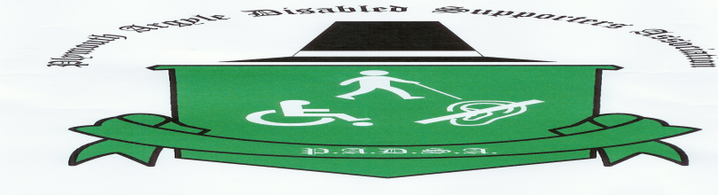

**www.padsa.co.uk** **/ info@padsa.co.uk / 07936542497**

**WINTER NEWSLETTER NUMBER 4**

**CHAIR’S UPDATE**

To all members and friends, we wish you a Happy Christmas and Joyous and a Happy New Year. We feel that 2014 has been a real success for PADSA. We have had several well supported social events and various fund raising functions. We are now in the position to be able to afford a few extra facilities in the newer side of the ground. The main achievement will be shortly the installation of RADAR key locks in all the disabled toilets to ensure they are only used by the disabled supporters with the correct keys and will be monitored by stewards on match days.

At the commencement of the redevelopment of the old grandstand many disabled will lose the parking spaces and with this is mind we are well on the way to being able to afford a golf buggy (we are still looking for donations or fund raising on ideas to help us reach the target).We are buying an adult and child wheelchair to help convey disabled supporters from the main car park to the ground. We understand there have been some issues where fans are blocking the views of disabled supporters. We have been reassured that this situation has been acknowledged by the management team and stewards are aware of the situation. If you have any problems please contact us so we can help in any issues.

We are sad to announce fellow committee member Harry O'Mahony. sadly passed away recently. We send our condolences to his family and friends.

Please remember without your continued support PADSA cannot achieve what it has in the last 12 months and I look forward to seeing you at our events.

Barry Hendy

**AGM**

This was held on September 10th.We were delighted that Carl McHugh, Anthony O'Conner and Luke McCormick joined us for the evening.

Those who attended enjoyed football bingo. A special thank-you to our Cornish supporters who came up for the evening.

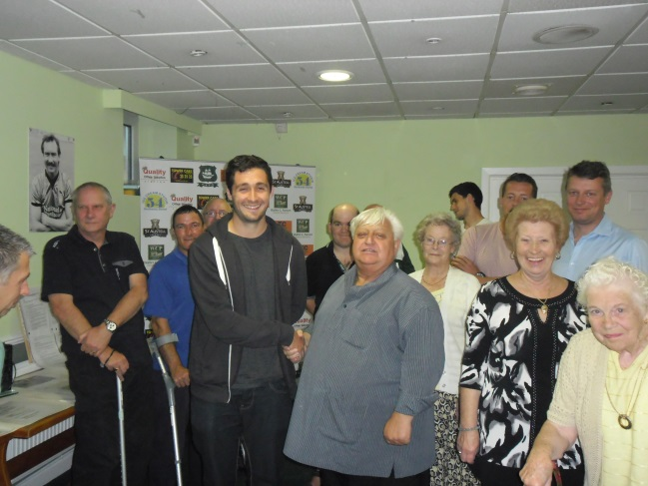

**Bucket Collection**

Our first bucket collection in August we collected £628.74

Thank-you to all who helped and donated.

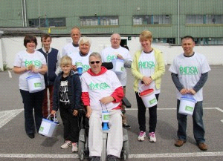 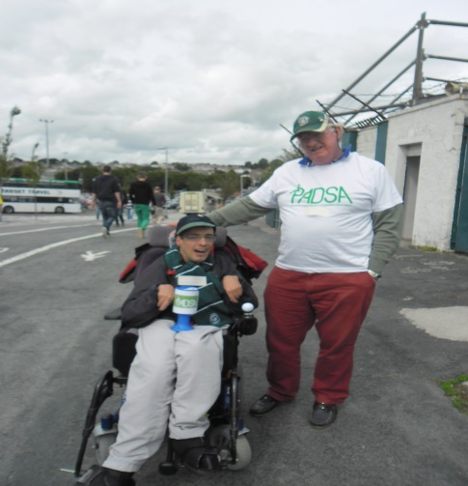

**South West Disabled Fans Experience Forum**

PADSA hosted this yearly event at Home Park on Thursday 16th October 2014 Delegates came from Cardiff, Swansea, Yeovil, Exeter football clubs as well as FA and Devon FA, members of the committee attended and Disabled Supporter Gareth Clark gave a speech on what it is like to be a disabled supporter at PAFC

**Carl’s Visit to Longcause Community Special School**

Carl McHugh and Anthony O’Conner along with Elaine James visited Longcause Community Special School in Plymouth. This was to donate match day tickets from our sponsored player to the children and young people who attend here. We have been informed that they all enjoyed having a kick about with real footballers!

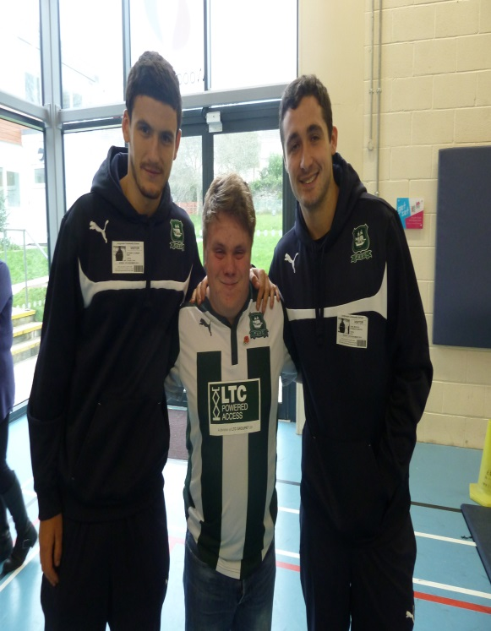

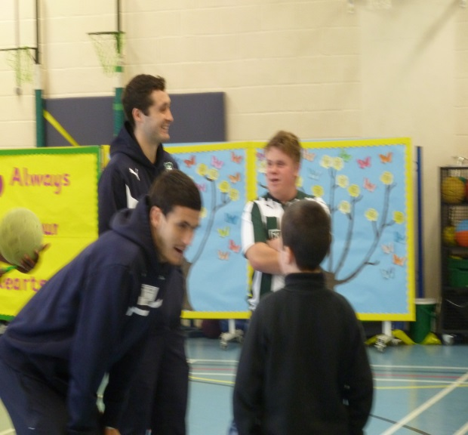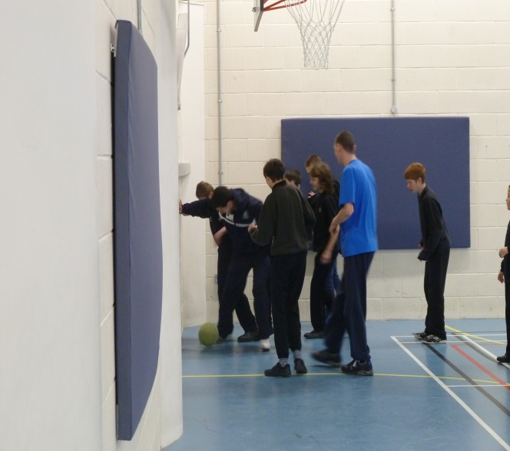

**New Project PADSA Catching Up With Social Media**

We are working Charlie Rose to produce some social media such a Utube to promote PADSA. We are looking for some fans to be part of the film action. If you would like to star in our film can you contact us. We hope to start this project in January 2015. Any ideas please contact us.

**Level Playing Field 2 Weeks Of Action March 2015**

To encourage more disabled supporters to attend and experience the Martyn Starnes has agreed for the disabled fans to have half price tickets to the home match on Saturday the 21st March 2015. More details to follow.

**Oxford Away Trip Saturday 14 March 2015**

We are hoping to plan this away trip for PADSA members to Oxford.

If you are interested in coming along with us we will require your name so we can plan the transport by the end of January 2015.

We have obtained information

Ticket Prices In Advance On day

Adult £19 £22

Concession £12 £13

Carer Free Free

Booking Fee 75p Postage 50p

Tickets will go on sale in February. Seating/Wheelchair Spaces will be in away section although shared with home disabled supporters.

**Cash For Your Empty Cartridges**

We are collecting empty Cannon, HP, Dell & Lexmark. So if you have any you can donate to us as it’s a way to fundraise for our group.

**Join Us At The Annual Carol Service**

Wednesday the 17th December 2014 at PAFC Devonport stand at 7pm. Committee members are attending

**Plymouth Argyle Disabled Supporters Association (PADSA)**

**Christmas Social Event** **Invitation**

The chairman and committee would like to invite you and your family to our Christmas social event on

**Sunday 14th December 2014 1.30pm to 4pm at The Tribute Lounge**

**Plymouth Argyle Football Club Home Park Plymouth PL2 3DQ**

The afternoon will include entertainment from Barry Francis and his keyboard melodies, singer Kyle Coleman, Christmas quiz, raffle, visit from Father Christmas and PAFC players and a Christmas tea.

The bar will be open.

**RSVP By 10 /12/ 2014**

**Please to Barry Hendy 01752 363909**

**PADSA mobile 07936542497 or email info@padsa.co.uk**

**Please can let us know if you have any dietary needs**

**We wish you a Happy Christmas and New Year**

PADSA Newsletter November 2014